Review of Treasury Management Activity 2019/20

Introduction

The council’s treasury management activity is underpinned by the Chartered Institute of Public Finance and Accountancy’s Code of Practice on Treasury Management (“the Code”), which requires authorities to produce Prudential Indicators and a Treasury Management Strategy Statement on the financing and investment activity annually. The Code also recommends that members agree a treasury management report after the end of each financial year.

Investment and borrowing decisions are taken in light of long term borrowing requirements, the estimated level of reserves and actual and estimated cash-flow. This is in the context of the current and forecast economic conditions. Consideration is also given to risks and compliance with Prudential Indicators. Therefore this report provides commentary on the following factors for 2019/20:

- Economic environment
- Borrowing activity
- Investment activity
- Performance against the Prudential Indicators

Economic Environment During 2019/20

The UK’s exit from the European Union and future trading arrangements, had remained one of major influences on the UK economy and sentiment during 2019/20. The 29 March 2019 Brexit deadline was extended to 12 April, then to 31 October and finally to 31 January 2020. The UK’s negotiations on the exit from the European Union together with its future trading arrangements drove volatility in the financial markets. The outcome of December’s General Election removed a lot of the uncertainty and looked set to provide a ‘bounce’ to confidence and activity.

The headline rate of UK Consumer Price Inflation fell to 1.7% in February, below the Bank of England’s target of 2%. Labour market data remained positive. The unemployment rate was 3.9% in the three months to January 2020 while the employment rate hit a record high of 76.5%.

Gross Domestic Product (GDP) growth in quarter 4, 2019, was reported as flat by the Office for National Statistics and service sector growth slowed and production and construction activity contracted on the back of what, at the time, were concerns over the impact of global trade tensions on economic activity. The annual rate of Gross Domestic Product growth remained below-trend at 1.1%.

However, COVID-19 spread across the globe in early 2020 causing falls in financial markets not seen since the Global Financial Crisis. In response to the spread of the virus and sharp increase in those infected, governments enforced lockdowns, central banks and governments around the world cut interest rates and introduced massive stimulus packages in an attempt to reduce some of the negative economic impact to domestic and global growth.

The Bank of England, which had held policy rates steady at 0.75% through most of 2019/20, moved in March to cut rates to 0.25% and then swiftly thereafter brought them down further to the record low of 0.1%. In conjunction with these cuts, the UK government introduced a number of measures to help businesses and households impacted by a series of ever-tightening social restrictions.

The US economy grew at an annualised rate of 2.1% in quarter 4, 2019. After escalating trade wars and a protracted standoff, the signing of Phase 1 of the trade agreement between the US and China in January was initially positive for both economies, but COVID-19 severely impacted sentiment and production in both countries. Against a slowing economic outlook, the US Federal Reserve began cutting rates in August. Following a series of five cuts, the largest of which were in March 2020, the Fed Funds rate fell from 2.5% to a range between 0% - 0.25%. The US government also unleashed a raft of COVID-19 related measures and support for its economy including a $2 trillion fiscal stimulus package. The European Central Bank held its base rate at 0% and deposit rate at -0.5%.

There has been a flight to quality in financial markets in response to the pandemic, resulting in Gilts yields falling substantially. For example the 10-year benchmark yield fell from 1% to 0.4%.

Treasury Management Portfolio 2019/20

In summary, the holdings at the beginning and end of the year were as follows:

 | 31/3/2020 | 31/3/2019
 | £m | £m
Long term borrowing | 844.6 | 478.7
Short term borrowing | 700.8 | 556.2
Total borrowing | 1,545.4 | 1,034.9
Long term investments | 300.6 | 326.8
Short term investments | 607.2 | 97.4
Total investments | 907.8 | 424.2

Borrowing Activity 2019/20

The Code requires that the council, in the medium term, only borrows for capital purposes (with the underlying need to borrow for capital purposes being measured by the Capital Financing Requirement adjusted for premiums and debt relating to other authorities). Total borrowing in the year was managed within the operational and authorised borrowing limits as approved in the Treasury Management Strategy which reflects the underlying need to borrow for capital.

In previous years, the council has pursued a policy of taking short term borrowing as short-term interest rates have been lower than long-term rates. This policy is reflected in the debt portfolio at the beginning of the year with a high level of short term borrowing. Consequently, the council had a significant requirement to replace existing short term borrowing in year along with a requirement to fund new capital expenditure.
Short term borrowing was continued during 2019/20. However, there is significant economic uncertainty and interest rates are at historically low levels. Therefore the benefits of re-balancing the debt portfolio and securing debt on a longer term basis to reduce re-financing risk and provide increased certainty of cost was regularly reviewed and it was considered an appropriate time to re-balance the portfolio during the year. As a consequence the year saw new long term Public Works Loan Board (PWLB) loans of £70m taken which have maturities in excess of 45 years. In addition, a £150m eighteen month loan was taken in March 2020 to secure liquidity in response to the COVID-19 pandemic which posed a potential risk to accessing finance.

Although the long term debt taken from the Public Works Loan Board has provided some long term security, it was still considered that the overall portfolio needed to be rebalanced with some more borrowing in the 5-10 year maturity period. The options for borrowing for five years included both the Public Works Loan Board and potentially directly with another local authority or bank. However local authority fixed deals are not too common for that period and the Public Works Loan Board rates were considered to be expensive, especially after the Public Works Loan Board took the decision to increase rates by 1% above Gilt rates.

The opportunity arose to work with the Municipal Bond Agency to work towards an initial bond issuance by the county council. It was felt that a five year bond would be an appropriate time period. Therefore in March 2020, the council issued a bond, the key features of which were as follows:
• £350m issued
• Five year maturity
• The principal is repaid on the maturity date, there is no obligation to pay earlier.
• Interest rates payable are variable and will be changed on specific dates linked to an indices (Sterling Overnight Index Average - SONIA)
.
Analysis of Borrowing Outstanding

 | Debt 31/03/2019 |  | Borrowing | Repayments | Debt 31/03/2020
 | £m | % | £m | £m | £m | %
Fixed Rate Funding
Public Works Loan Board | 235.6 | 22.8 | 220.0 | (7.5) | 448.1 | 29.0
Market Borrowing | 602.8 | 58.3 | 930.8 | (979.3) | 554.3 | 35.9
Total Fixed Rate Funding | 838.4 |  | 1,150.8 | (986.8) | 1,002.4
Variable Rate Funding
Public Works Loan Board | 125.8 | 12.1 | 0.0 | 0.0 | 125.8 | 8.1
Bond | 0.00 | 0.0 | 350.0 | 0.0 | 350.0 | 22.6
Shared Investment Scheme | 70.7 | 6.8 | 515.3 | (518.8) | 67.2 | 4.4
Total Variable Rate Funding | 196.5 |  | 865.3 | (518.8) | 543.0
Total Loan Debt | 1,034.9 |  | 2,016.1 | (1,505.6) | 1,545.4

Overall the average rate of interest paid in 2019/20 on the debt administered by the council was 2.05% per annum compared with an average rate of 2.1% in 2018/19.

The council did not enter into any new 'other long term liability' arrangements in the year. The outstanding Private Finance Initiative liability at 31 March 2020 was £146.6m.

Investment Activity

The council invests its reserves and other cash balances. The total value of investments held (excluding fair value adjustment), at 31 March 2020 for treasury management purposes was £907.8m. This was £483.6m higher than at 31 March 2019. The table below shows the investment holdings and the movements during the year:

Maturity Range | Position at 31/3/2019 £m | 2019/20 Movement  £m | Position at 31/3/2020  £m
Call accounts and under 1 year | 97.4 | 492.4 | 589.8
Bank deposit 1-2 years | 1.3 | -1.3 | 0.0
Bank & local authority deposits 2-3 years | 0.0 | 0.0 | 0.0
Bank & local authority deposits 3-5 years | 0.0 | 10.0 | 10.0
Bank deposit 5 years + | 10.0 | -10.0 | 0.0
Local authority bonds | 33.2 | -0.4 | 32.8
UK Government and supranational bonds | 282.3 | -7.1 | 275.2
Total | 424.2 | 483.6 | 907.8

In addition to the investments made for treasury management purposes, the non- treasury management investment strategy permits the investment in bonds for commercial purposes where cash-flow permits but investments outside the current treasury management credit matrix will only be incurred after agreement with the Director of Finance. Under this arrangement investments have been made in local authority Lender Option Borrower Option (LOBO) loans and EDF (an energy company) corporate bonds. As changes in market values are charged the general fund, the council has entered into a short trade which means the council agree to buy some bonds at a specific price in the future. The net value of the non-treasury management investments at 31 March 2020 is £208.5m. Total investments at 31 March 2020 are therefore £1,116.3m.

In undertaking investments consideration is given to the risk and liquidity within the portfolio which are affected by the maturity of the investment, asset type, country invested in and the credit rating. This includes those that are deemed to be non- treasury investments. The position of the investment portfolio on these areas are reviewed as follows.

Investments by Maturity
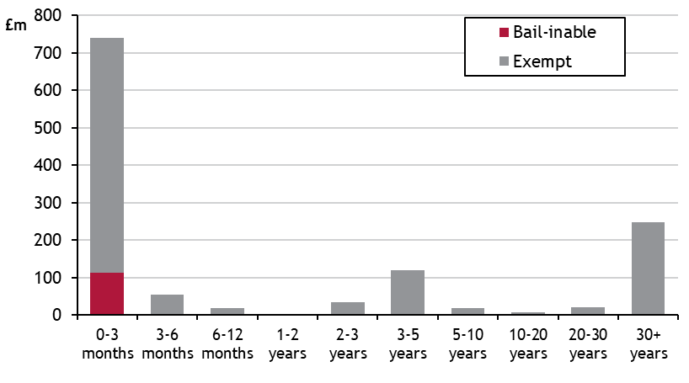
The graph shows the maturity dates of assets along with the exposure to bail-in, in the event of a bank default (i.e. the risk that the investment may be lost or the principal repaid significantly reduced). As can be seen the exposure to bail-in is relatively low and arises mainly in the short term with the use of call accounts. The very long term investments are principally investment in the UK government via Gilts. Therefore the credit risk is low and the assets are saleable and do not have to be held to maturity thereby allowing the market risk to be managed.

Total investments analysed by asset type Total Investments analysed by Country
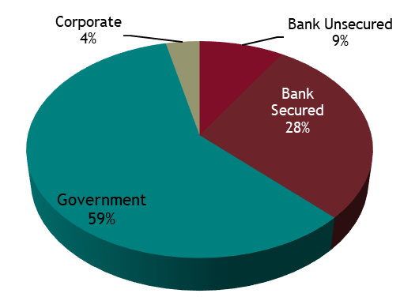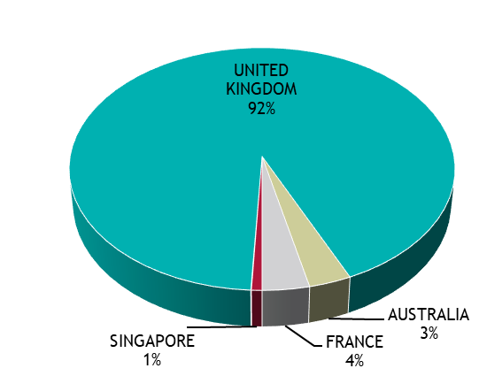
Total Investments analysed by credit rating

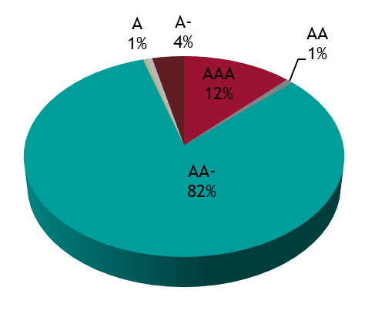
Security

Security of capital remained the council's main investment objective. This was maintained by following the council's Counterparty Policy, as set out in its Treasury Management Strategy Statement for 2019/20. This defined “high credit quality” organisations as those having a minimum long-term credit rating of A+. In practice, the average credit rating in 2019/20 was higher at AA.

Investments with banks were held in call accounts only. Any longer term deposits have been restricted to deposits with other local authorities.

Liquidity Management

The council maintained a minimum level of primary liquidity through the use of Call Accounts. The council also has bond portfolios which are available for sale, at current market prices, if needed as “secondary” liquidity.

The council undertakes cash flow forecasting daily to determine the maximum period for which funds may prudently be committed.

Yield
The rates of return on the council's short-dated money market investments, reflect prevailing market conditions and the council's objective of optimising returns commensurate with the principles of security and liquidity.

Overall the treasury management investment portfolios returned an average rate of 5.73% in 2019/20 which can be attributed to the categories as follows:

Maturity Range | Average Balance £m | Average Rate
Call and under 1 year | 119.4 | 0.37%
Bank & local authority deposits 3-5 years | 10.0 | 2.95%
Bank & local authority deposits 5 years + | 0.000 | 0.00%
Local authority bonds | 33.0 | 3.76%
UK government & other bonds | 474.7 | 7.28%
Total | 637.1 | 5.73%
In addition, the non-treasury management investments had an average balance of £314.7m which made a net return of 0.29%.

Impact of the Treasury Management Strategy on the Council's Revenue Budget

The financing charges budget covers both the treasury management and non- treasury management activities. In total there was a net underspend of £22.9m as shown in the following table.

 | Budget | 31 March 2020 Actual | Variance
 | £m | £m | £m
Minimum Revenue Provision | 14.9 | 14.9 | 0.0
Interest paid | 25.0 | 30.7 | 5.7
Interest received/surplus on sale | (13.9) | (42.5) | (28.6)
Total | 26.0 | 3.1 | (22.9)

Income received in the year was £28.6m higher than budgeted. Although investment balances were higher than budget, the main reason for the increase was the gains on the sale of Gilts. With the markets responding to economic and political events there was volatility in the price of Gilts and other bonds. It's not possible to reliably predict the movement in the financial markets and therefore to assess the potential for gains for inclusion in the budget.

Interest paid was higher than budget due to the level of borrowing being higher than anticipated. Securing the long term loans involved some additional cost and the fees incurred on issuing the bond were charged in-year.

Treasury Management and Prudential Indicators 2019/20

The Local Government Act 2003 and supporting regulations require the council to have regard to the Prudential Code and to set prudential indicators to ensure the council's capital investment plans are affordable, prudent and sustainable. A comparison of the actual position at 31 March 2020, compared to the 2019/20 indicators set in the Treasury Management Strategy, is set out as follows. All activity in the year complied with the Prudential Indicators and Treasury Management Policy Statement for the year.

Prudential Indicators
Authorised limit for external debt | 2019/20 | Actual
The authorised limit is a prudent estimate of debt which reflects the council's capital expenditure plans and allows sufficient headroom for unusual cash movements.
 | £m | £m
Borrowing | 1,600 | 1,545
Other long term liabilities (private finance initiative schemes) | 150 | 146
TOTAL | 1,750 | 1,691

Operational boundary for external debt | 2019/20  £m | Actual  £m
The operational boundary is a prudent estimate of debt but has no provision for unusual cash movements. It represents the estimated maximum external debt arising as a consequence of the council's current plans.
Borrowing | 1,500 | 1,545
Other long term liabilities (private finance initiative schemes) | 150 | 146
TOTAL | 1,650 | 1,691

Capital Financing Requirement to Gross debt | 2019/20  £m | Actual  £m
Capital Financing Requirement | 1,105 | 1,092
Estimated gross debt | 1,194 | 1,691
Debt to Capital Financing Requirements | 108% | 155%

The Capital Financing requirement is the underlying need to borrow for capital purposes. This is the cumulative effect of past borrowing decisions and future plans. This is not the same as the actual borrowing on any one day, as day to day borrowing requirements incorporate the effect of cash flow movements relating to both capital and revenue expenditure and income.

Treasury Management Indicators

Interest rate exposure | Upper Limit  £m | Actual  £m
The limit measures the council's exposure to the risk of interest rate movements. The one year impact indicator calculates the theoretical impact on the revenue account of an immediate 1% rise in all interest rates over the course of one financial year.
1 year impact of a 1% rise | 30.0 | (30.7)
Maturity structure of debt  Limit on the maturity structure of debt helps control refinancing risk. | Upper Limit % | Actual %
Under 12 months | 75 | 45
12 months and within 2 years | 75 | 13
2 years and within 5 years | 75 | 25
5 years and within 10 years | 75 | 3
10 years and above | 75 | 14
Minimum Average Credit Rating | Benchmark | Actual
To control credit risk the council requires a very high credit rating from its treasury counterparties.
Average counterparty credit rating | A | AA

